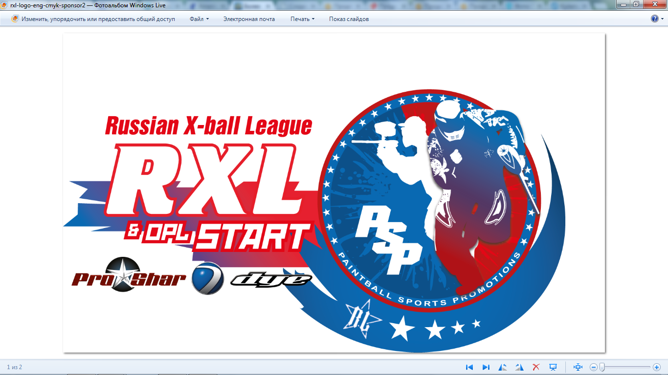
Russian Holidays – Div1, 13|14 июля2013 года
Суббота 13 июля
1 Sat 9:00 Desperados vs Grad Moscow
2 Sat 9:30 Grad Kidz vs YaD
3 Sat 10:00 Force Majeure vs Dozor Moscow 2
4 Sat 10:30 Chernaya Metka vs IDDT
5 Sat 11:00 Command A vs Dozor Moscow
6 Sat 11:30 Moscow Red Legion vs San Diego Dynasty
7 Sat 12:00 Grad Moscow vs ZZ OBOROTNY
8 Sat 12:30 Grad Kidz vs Dozor Moscow 2
9 Sat 13:00 Desperados vs Force Majeure
10 Sat 13:30 YaD vs Chernaya Metka
11 Sat 14:00 Command A vs San Diego Dynasty
12 Sat 14:30 Dozor Moscow vs ZZ OBOROTNY
13 Sat 15:00 Dozor Moscow 2 vs Moscow Red Legion
14 Sat 15:30 Desperados vs IDDT
15 Sat 16:00 Grad Moscow vs Chernaya Metka
16 Sat 16:30 YaD vs Command A
17 Sat 17:00 Force Majeure vs San Diego Dynasty
18 Sat 17:30 Grad Kidz vs Dozor Moscow
19 Sat 18:00 Desperados vs Moscow Red Legion
20 Sat 18:30 IDDT vs ZZ OBOROTNY
Воскресенье 14 июля
21 Sun 9:00 Dozor Moscow 2 vs IDDT
22 Sun 9:30 YaD vs ZZ OBOROTNY
23 Sun 10:00 Grad Moscow vs Command A
24 Sun 10:30 Grad Kidz vs San Diego Dynasty
25 Sun 11:00 Force Majeure vs Dozor Moscow
26 Sun 11:30 Chernaya Metka vs Moscow Red Legion
1/4
27 Sun 12:00 А3 vs А6
28 Sun 12:30 А4 vs А5
SemiFinal
29 Sun 13:15 A1 vs win28
30 Sun 13:45 A2 vs win27
Final
31 Sun 14:30 lose29 vs lose30
32 Sun 15:00 win29 vs win30

